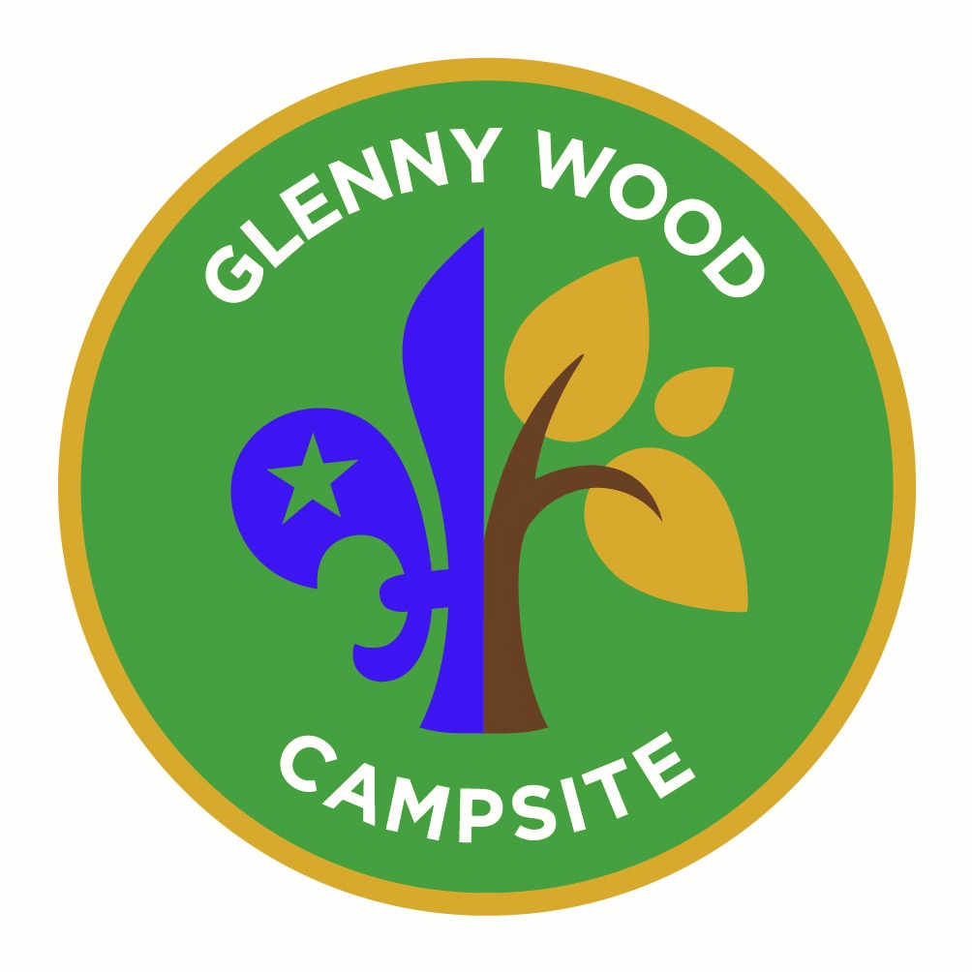
Glenny Wood
Treasure Hunt Quiz

All the answers can be found in the Glenny Wood Camp Site

No | Treasure Hunt Question | Your Answer is -
1 | When was Glenny Wood first used by Gordano Scouts?
2 | What is at 5 Mead Court?
3 | How many lights on the drive from the gate to the lodge?
4 | What’s the number in an emergency?
5 | What are you allowed to leave at Glenny Wood?
6 | How many entrance doors into the tunnels?
7 | Name the stepped plateau trees (five to be named)
8 | How many colours on the Gordano badge?
9 | What is the score on the tree by the darts board
10 | What pole can you see from the karts track?
11 | What type of ball would you enjoy at the Court
12 | What must you always take when it’s wet?
13 | What should you wear on the log?
14 | How many logs in the Rowan circle?
15 | How many tyres on the Confidence Course
16 | Find tree 100 in the Wetlands. What type is it?
17 | How many bars on the gate into the Wetlands
18 | Where would you find a reminder of Don McKinnon?
19 | Who has happy memories at Glenny Wood?
20 | Which colour has 26 boulders?
21 | Where is the Assembly Point?
22 | What is highly poisonous?
23 | What do you put in your socks to avoid Lyme Disease
24 | What is the Childline number?
25 | What can you take from Glenny Wood?

