Glenny Wood Fact sheet - Snookball

Aim of the game
To win the game, the player must pocket all their balls and then the blackball.

Initial ball set-up
For snookball, the balls are arranged using a triangular rack. The black ball is placed on the white spot in row 3. All the other balls are placed around the black ball in alternate spots and stripes.
Snookball is a hybrid sport that blends pool with football. The principle of the game is based on pool, but the balls are replaced by footballs and the cue by a pair of feet. The name Snookball comes from a legendary pool move: the snooker, which occurs when a player is obstructed from taking a shot in a straight line by an opponent's ball.
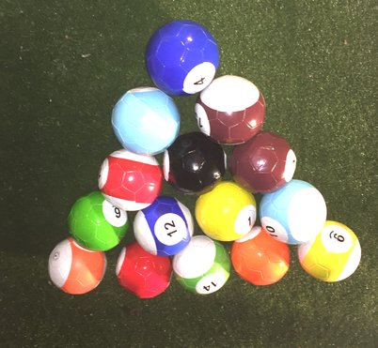
When a player successfully pots their own ball they shoot again until they miss or foul.
Key to success on the Glenny Snookball court is to use skill and control when kicking the white cue ball. To whack it, usually means the white ball or target ball or both end up going out of the court. So off you run to collect

The Break
The player places the white ball on the white spot opposite the balls. A break is valid when the white ball hits another ball in the triangular group seen above

Regular shots
A player's turn lasts as long as they keep legally potting balls, until they miss a shot or commit a foul.

Missed shots
After a missed shot, the opponent who takes over should resume play with the white in the position where it was left.

Fouls
When a player commits any of the following fouls, the opponent can take two free shots as long as they do not commit a foul on their first attempt:
- Hitting a ball that is not one of theirs
- If the white ball does not hit any balls

When a player commits any of the following fouls, the opponent can place the white ball back to the white spot or along an imaginary line from side to side through the white spot and shoot from there. They get two free shots as long as they do not commit a foul on their first attempt:
- Pocketing the white ball
- Hitting the white ball off the court
- Balls pocketed during a foul are not put back onto the court.

If you pocket the black ball before pocketing all your balls, either spots or stripes, you forfeit the game.

Winning the game
You win the game by pocketing all the balls that you have to, either the spots or stripes. Once all your balls are pocketed you then must pocket the blackball.
Tips on playing the game
Use skill and line up your shots
Do not use too much power or whack the white ball
Try and pocket your balls or get them close to a pocket
Try and make the shot for your opponent as difficult as possible, as long a distance between the white ball and their balls or snooker them or try and get the white ball near the side cushion.

Players - This can be 1 v 1 or 2 v 2 or more. When it is not a players go they can stand up on the side cushion, keeping their feet tucked in. DO NOT SIT ON THE RAILINGS.
To play Snookball on the Glenny Wood Court all players must REMOVE THEIR BOOTS / SHOES / TRAINERS OR OTHER FOOTWEAR please… therefore All games must be played in bare feet or feet with socks on.

I am sure you will find many more ways to play the game.

Enjoy and have
FUN

Packing away - Snookball

At the end of your activity the least favourite activity is packing up. Below is a check list to be followed, to help you with the packing up and I hope make things much quicker.....

- All balls to be and wiped with Antiseptic wipes and then locked in the box provided
- Please leave the court clean and tidy
- Court to be locked and numeric padlock well scrambled and wiped with Antiseptic wipes
- Don’t forget to take away with you shoes / socks / coats etc and any rubbish.
- Leaders please ensure this is all completed and not just left to the young people (Young Leaders)

Any damage please report through booking@glennywood.org.uk
It is important this is done please and not left for others to discover.

Any pictures of the activity you are willing to share please email to booking@glennywood.org.uk

