Sheep Penning

Sheep Penning is a great challenge which helps to build and develop team working, leadership, communication and problem solving.

The Game - is to get the sheep, between 3 and 6 into the pen without the shepherd moving or speaking as the only means of communication is a whistle.
The game is best with one shepherd and between 3 - 6 sheep.

And for hygiene
FOR THIS GAME YOU WILL NEED TO SUPPLY A WHISTLE.
Please remember to clean the whistle thoroughly after each game.

No sheep needed to play this game!!

Equipment provided
- Laminated instructions
- Plastic rope
- 5 pegs
- 6 Blindfolds

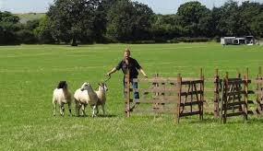

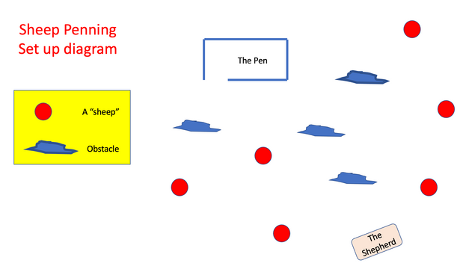
Set up - This is straight forward, just Peg out a sheep pen in the grass using the blue rope provided.
Leave about a metre wide gap to be the gate.

You may also wish to put a few obstacles in the area for the sheep to have to manoeuvre around!

Getting ready to play - The shepherd and the sheep (all young people) need to work out how they are to communicate, with the shepherd only using the whistle, not talking at all, staying in one area and also taking into account sheep will be blind folded. Then take them out onto the plateau. We suggest this part should be completed in 10 minutes
Examples of whistle code they will need to play the game include:-
- identify each individual
- stop / go
- Turn left / right/ forward / backwards…
- Etc…..

Lets get started - So once the team are happy they have worked everything out they are ready to play.
1 - the shepherd takes a position, not near the pen or sheep but with a clear view over everything. They need to stay in this position
2 - Blind fold the sheep. Then one at a time take the sheep out to their starting place. It’s also a good idea to give the sheep a spin on the way out to disorientate them. Once in position, not necessarily facing the shepherd or the pen they are ready to start.
3 - Once everyone is in place then tell the shepherd to start
4 - You may wish to time to see how long it takes to pen those sheep

Please remember - The adult leader should not be participating. Their role is to watch what’s happening to make sure there is no cheating and critically that the blindfolded sheep do not put themselves in a dangerous position or likely to hurt themselves, ie walk into a hedge, slide down a bank etc…..

DON’T FORGET FOR THIS GAME YOU WILL NEED TO SUPPLY A WHISTLE.
Please remember to clean the whistle thoroughly after each game.

And finally - Please put all the kit back in the box when finished and lock in the activities shed locker.

