FACTSHEET –
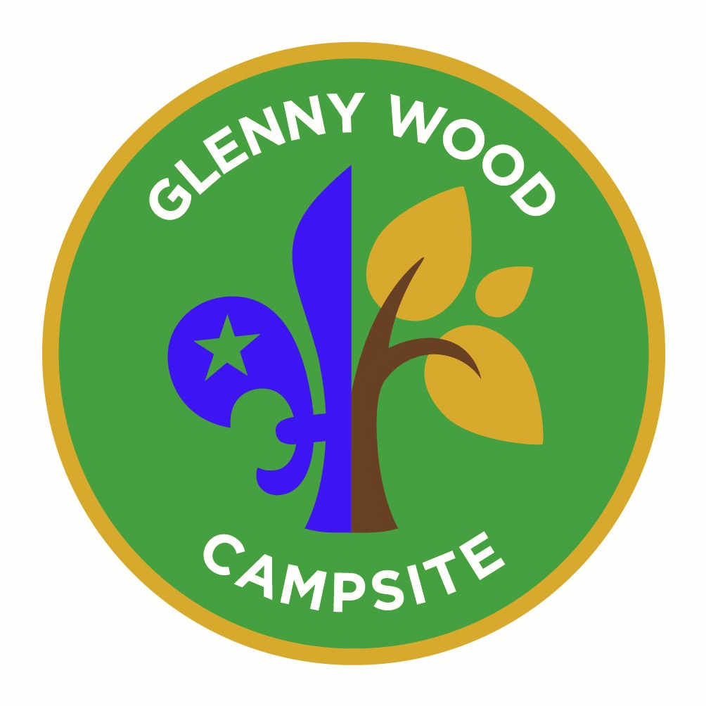

Camping at Glenny Wood

Glenny Wood is a great place to camp. The site is split into 11 camping plateaus. The site lends itself well for all types of camping as the areas differ in size and are easy to access and use.

The camping areas –

Apple – Is our largest plateau, which gently slopes towards the lodge and loos. An ideal camping area. This area is flat and 77 meters long, and 31 meters wide This good size area 4-6 patrol tents and kitchens or 25+ 2 person hike tents

Beech Plateau - An ideal camping area, below the lodge. This area is flat and 38 meters long, and 13 meters wide This good size area can accommodate 3/4 patrol tents and kitchens or 10+ 2 person hike tents

Hawthorne Plateau - This is a small plateau is a small sloping plateau below the Activities area. It is approximately 18 meters long and 10 meters wide, variable. The plateau can accommodate 4 or 5, 2 person hike tents, pitched on the slope Hawthorne is an ideal base for the evening visit to Glenny and central to the site

Hazel Plateau - Hazel is a small plateau which is 50% "flatish" and near to the loo block. It is approximately 43 meters long and 10 meters wide. The flat area of the plateau accommodate 2/3 patrol tents and kitchen and overall 8-10 2 person hike tents.

Stepped Plateaus – Group of 5 camping plateaus as below
- Stepped Plateaus - Oak - An ideal camping area, flat and 22 meters long and 4 meters wide increasing to 9 meters wide at the end “bubble”. This good size area 1 patrol tents and kitchens or 5 + 2 person hike tents. Being at the top of the plateaus this is a great site for seeing what’s happening below, idea for Leaders perhaps!

- Stepped Plateaus - Birch - An ideal camping area, flat and 48 meters long and 3 meters wide increasing to 7 meters wide at the end “bubble”. This good size area 2 patrol tents and kitchens or 7 + 2 person hike tents

- Stepped Plateaus - Spruce - An ideal camping area, flat and 52 meters long and 5 meters wide. This good size area 3/4 patrol tents and kitchens or 10 + 2 person hike tents

- Stepped Plateaus - Cherry - An ideal camping area, flat and 49metres long, and 5.5 meters wide increasing to 7.5 meters wide. This good size area 2/3 patrol tents and kitchens or 10 + 2 person hike tents

- Stepped Plateaus - Ash – our smallest plateau at the bottom of the plateau area. It is 15 meters long and 8.5 meters wide. The plateau has a small flat area – one patrol tent and kitchen or 5 + 2 person hike tents. Idea for kitchen / communal tents as there is hard standing on this area.

Sycamore Plateau -
Sycamore is a small plateau just inside the inner gate on the site. it is roughly 20 metres square and flat. This shaded plateau will accommodate 2 patrol tents or 10 x 2 man hike tents.....

Willow Plateau - Willow is a plateau just below the stepped plateaus. it is roughly 40 x 30 metres at its widest and is a sloping. This plateau will accommodate 4 patrol tents or 15 - 20 x 2 man hike tents......

Health and Safety - Site Safety information - https://glennywood.org.uk/home/safety/

Windy weather policy statement - When forecasted wind speeds reach 32 mph level, Glenny Wood site management reserves the right to close the site. Anyone on site will be required to leave. https://glennywood.org.uk/home/safety/

LPG – There is an LPG tank on site which is out of bounds. A separate fact sheet and risk assessments area available for this, please familiarise yourself with these when using the site. –

First Aid - Section Leaders are expected to bring and use their own First Aid kit when using the site and manage situations as they arise. Emergency first aid kits are available on site, in the loos. https://glennywood.org.uk/home/health-1/

Ticks (Lyme disease) – Being a wooded area Ticks are about, so remind those on site to check for Ticks https://glennywood.org.uk/home/health-1/

Accidents – You should be reported as per your organisations procedures, and let the Glenny team know on mail@glennywood.org.uk

Dogs – No dogs on site, except guide dogs and police dogs.

Glenny Souvenir Shop - We have a range of badges, magnets, pencils, woggles etc for site users to purchase to remember their visit / stay at Glenny Wood. https://glennywood.org.uk/home/shop-new

Rubbish - We have no method of rubbish disposal, therefore please take all rubbish home with you or take it to the local recycling centre…Black Rock Quarry, Valley Road, Portishead, BS20 8JY

Cleaning and Tidying When leaving – Please ensure you leave the site clean and tidy, ready for the next users:-
- leave your camping areas and areas used clean, free of litter and tidy
- turn off the fridge / freezer, the socket is above the appliance, ensuring it is clean and both doors left open in the campers shed, unless there are others on site.
- Clean toilets / showers and all areas used
- Litter sweep the site.
- Put all unburnt wood back in the wood pile
- Return the altar fire to the storage area
- Lock up all the padlocks and thoroughly scramble the codes.

Photos - We welcome any photos to use on our website of your adventures at Glenny

Thank you for using our fabulous site and have a great time and please remember -

Take nothing but photographs and memories – leave nothing but footprints

Reviewed & Updated – Jan 24

