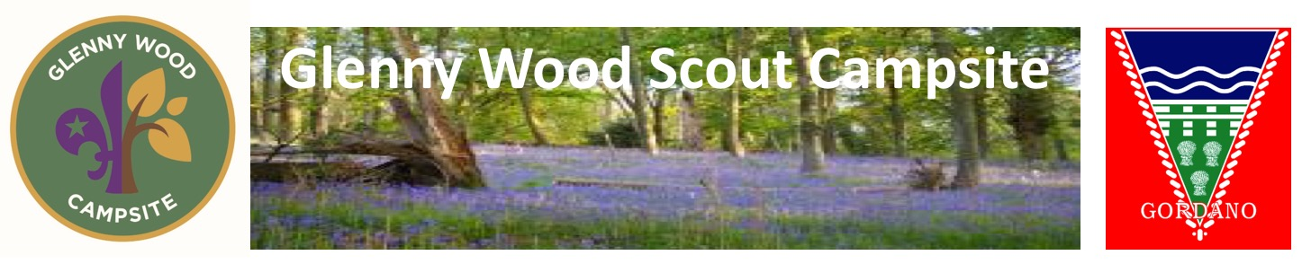
Day / Evening Visit and Activities Booking Form

Details of section, dates and times

Event Start date & Arrival time |  | Departure time
Group |  | Section
District |  | County
Numbers of Young People (U18) |  | Number of Adults
Event Leader name |  | Role in the organisation
Mobile Number |  | Role in the organisation
E Mail address

Glenny Lodge
I wish to book the lodge for the following date …………… and times – From………. to …………..
(maximum of 24 hours, then please book using camping / lodge form.)

On site areas and Activities to book
CAMP FIRE AREA - Please indicate if you wish to use our two Ground Fire areas.

 | Tick | Day (s) | Time - from | Time - to
Main Camp Fire Area (below the lodge)
BBQ / Ground Fire area on Willow Activity Plateau

GLENNY WOOD ACTIVITIES – bookable - Activities available to book therefore are –

Activity | Charge |  | Day(s) requested | Approx’  Times
Tunnels ^{Helmets supplied} | £1 per person - max two hours.
Grass Sledges ^{Helmets supplied} | £5 per Sledge for a max of 2 hours
Pedal Karts ^{Helmets supplied} | £5 per Kart for a max of 2 hours
Aerial Runway – (Training need to be able to use this activity. – see website for training dates) | £20 per session for a max of 2 hours
Snookball – ^{Giant pool!} | £10 per session for a max of 2 hours
Pioneering Poles & Blue rope. | £10 per session for a max of 2 hours.
Wetlands area – Pond dipping / bug collecting / conservation spotting | £10 per session for a max of 2 hours
Gordano District only
A combined fee of £25 for use of all above activities or combination there off |  | Please tick which activities you wish to book

GLENNY WOOD ACTIVITIES/EQUIPMENT – free for site users. - Activities/Equipment below are free and available on site for your group to use. Please confirm when you would like to use the activities / equipment below, so we can help maximise usage. When on site please liaise with other site users to use these activities.
Activity  Below are activities on site which are free to use | Day(s)  requested | Approx’  Times
Confidence Course
Safety Helmets (Recommend these should be worn when using confidence course)
Games Shed housing large games – chess, jenga, knubb, connect four, kwik cricket, skittles, dominos, target frisbee
Site service projects
Other Scouting equipment available upon request

OTHER LEADER LED OWN ACTIVITIES

Please let us know what you are planning to do at Glenny, so we can ensure everyone has space to do their own activities….Also its always a help if you know the site to please indicate if there is a specific area you wish to undertake the activity | Day(s)  requested | Approx’  Times
Backwoods Cooking
Bivouac Building (in the wooded areas please and please clear away when finished )
Wide Games
Wet evening / water fights
Or what else have you planned, please just let us know?

All activities must be leader supervised. Leaders are responsible for the young people on these activities, have undertaken risk assessments and comply with Scout Association POR / factsheets
or with your own organisations rules & guidelines.

Draft risk assessments to assist you with this and site fact-sheets, for site users to follow, can be found at - http://glennywood.org.uk/Risk%20Assessments.html

GLENNY SHOP http://glennywood.org.uk/shop.html - I would / would not like the Glenny Shop / Scout Shop open when we are on site (memorabilia etc… not sweets / drinks.)

PAYMENT - Once you have used Glenny Wood – will you please email, booking@glennywood.org.uk to confirm your numbers using the site, along with any equipment / activities used and you will be billed for the remaining amount outstanding. Payment to be made within 14 days of invoice date please. Late payments will incur a 10% surcharge. We can also send out shop orders and include on the bill if we don’t make a shop opening time……
Payment arrangements - Electronic payments preferred and direct to our bank account
Sort code – 30-18-88 and Account number – 00678723.
Alternatively, Cheques payable to “Glenny Wood Scout Camp”.
Please quote your section name as the reference.

BOOKING REQUEST DECLARATION - I confirm the details and booking as per this form, and that the camp will be run under Scout Associations POR and guidelines / my organisation rules and guidelines.

By making this booking I agree I have read and will follow the Glenny Wood moto, website and Factsheets, including:
1 - using the site and camping - for all to read
2 - using the activities and facilities on site - for all to read
3 - using the lodge - for those hiring this building and patio area only

Where young people are on site I confirm all adults will have an in date, valid, Disclosure and Barring Service (DBS) check

Signed………………………………………………..Event Leader Date ………………………..

Name………………………………………………….. Role ……………………………

If this form is returned by email, the email is accepted as your online signature
as if you had signed the form.

Please return this form to Phil – booking@glennywood.org.uk
01275562102 - (No text messages)

