Glenny’s very own - Squirrel Trail

This activity is a chance for you to explore Glenny and have a lot of fun finding the Squirrel signs around the site.

You will need for each individual / group you are sending out on the course
- Copies of the Map
- List of points
- 2 x Pencils to record finds
- Clipboard is handy

There are 26 numbered signs (1-26) - with letters A to Z on them placed within the site for you to find and make a note of the letter.

To undertake this activity there are various ways you can run it,

With the MAP

A - Give the Young People a copy of the Map with the signs position marked, in red, and numbers and they are ready to go…..

B - Give the Young People a copy of the MAP with just the signs position marked, in red, and they have to number them

C- Give the Young People a copy of the MAP with just the signs position marked, in red, and in advance you have added the numbers to the signs position dots you wish them to go to.

D - Give the Young People a blank copy of the MAP and they have to mark the positions and also number them

Please note you will need to print a master map per couple of groups for the YP to copy from. Don’t forget to collect the master map before they go sign hunting!!

3 suggestions below on how to then run the evening….

1 - Explore and just collect the letters - set a target of say 10 letters in 40 minutes…..

2 - Similar to one, although this time collect all the letters and use them to complete the anagram …. You can either use our examples or make up you own.

3 - As you will see in the sheets each letter has a value against them. Set a number and the young people go to the point make a note of the letter and then they get the points…. You could do this a couple of ways -
- Points collected when added together must equal a specific number.
- Points when collected must be greater than

We have the answer details for the course, although this is not published on the website. To request the answer sheet please complete the simple form here

Risk Assessment - We have a draft to assist you in completing your assessment. This can be reviewed at https://glennywood.org.uk/home/safety/risk-factsheets

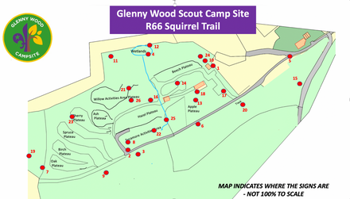
PDF Copy of - Squirrel Trail Map, Locations and Numbers
>>>>

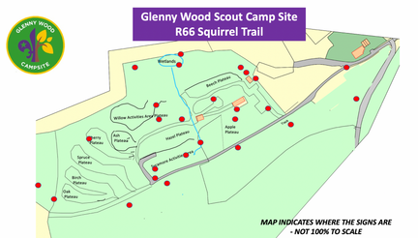
PDF Copy of - Squirrel Trail -
Map and Locations
>>>>

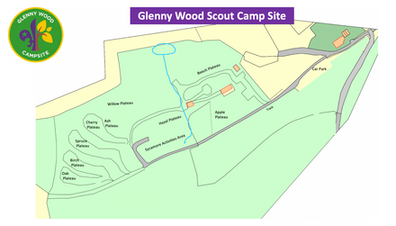
PDF Copy of -
Blank Glenny Wood Site Map
>>>>

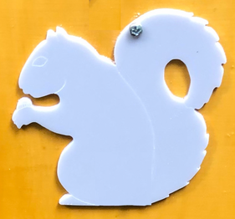
Squirrel Trail numbered locations
clues and points list
>>>>

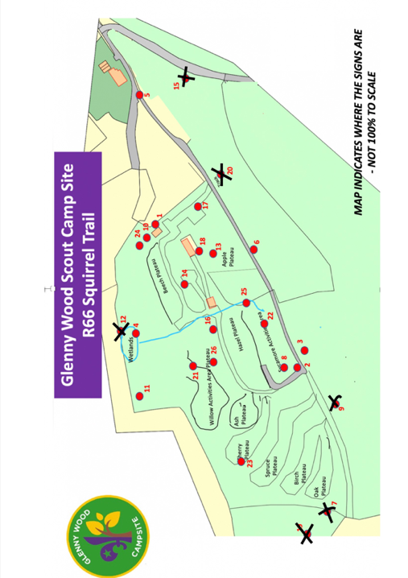
Squirrel Trail
Short Course
>>>>

