Radio Active Logs

Radio Active Logs is a great challenge which helps to build and develop team working, leadership, communication and problem solving.
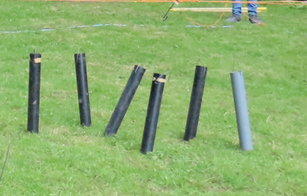
Equipment
- Laminated instructions
- Long Plastic rope
- Hook with 6 plastic lengths attached
- 6 posts
- Mallet
- 6 Radio Active logs.

The Game -
The challenge is to remove the radio active logs (all not dangerous!!) from inside the circle to outside the circle, using only the rope and hook attached to it.
The area within the circle is radio active, so cannot be walked on!
If a log is dropped on the way out, it won’t explode, just pick it up with the hook and carry on.
Once all logs are removed the challenge is completed
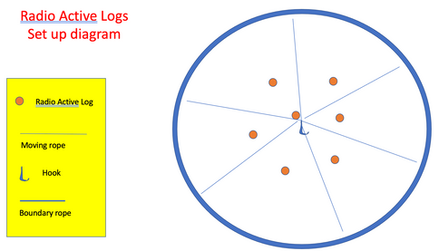
Set Up
1 - To set this out lay out the ropes attached to the hook
2 - Lay out the long blue rope in as large a circle as you can.
3 - In the centre area, spread out a little, knock in the posts and put the radio active logs on them, with the metal hook area facing upwards
4 - You are now ready to start.

Playing the game
Number of players between 3 and 6
Give the team no more than 3 minutes to plan what they intend to do.
Each player holds one rope
The players can move anywhere around the outside of the circle, but not in it.
Working together and communicating well they collect the logs and drop outside the circle
If you have more than 1 team planning to take up the challenge you can always time how long it takes to complete.

Packing Up
Once finished please tie up the ropes attached to the hook individually and put all the kit back in the Blue Bag and lock in the activities shed locker.
(To tie up the rope you should; fold the rope in half 4 times and tie off.)

